### **Reverie Reading Documentation**

### How to interact with Reverie Reading application:

Admin functionality:

The Admin user experience is different the customer user experience. To access and use the Admin functionality, use the following login credentials:

Username: admin

Password admin

Stripe API functionality:

1. To use and test the Stripe API you will need to be registered and logged in as a general user. Then simply select an item from the Products page. You will be redirected to the Product Detail page.
2. Once inside of the Product Detail page, click the Add to Cart button, this will redirect you to the cart page.
3. Now located on the cart page, you can select to continue shopping and repeat steps one and two or continue to step 4.
4. Now select the Proceed to Checkout button, you will be redirected to the Stripe API payment and address confirmation page.
5. In the Stripe shipping and payment form, please use a fake email and shipping address. For the card information you can use the following details:

Card Number: 4242 4242 4242 4242

DD/MM: 02/24

CVC: 123

1. If the payment is successful, you will be redirected to the home page.

Application Build Process and Overview

Week 1

Overview:

This week has been spent researching and conceptualizing an idea that is necessary as an application but also fits the requirements of the assignment. This weeks' time has also been devoted to developing a presentation around the research findings and preparing to present the information gathered to our UCD instructors and peers. Currently no code has been written for this project.

### Week 2

Overview:

The beginning of this week was spent finalizing the planning process for my ecommerce application. The technology stack has been chosen with the specification of the application in mind. The mockups have been designed and the application has been broken down into features and dependencies necessary for this application. The site map, navigation logic, potential challenges and contingency plans have also been developed and the initial development of this project has begun. All supporting images are displayed below.

Technology Stack:

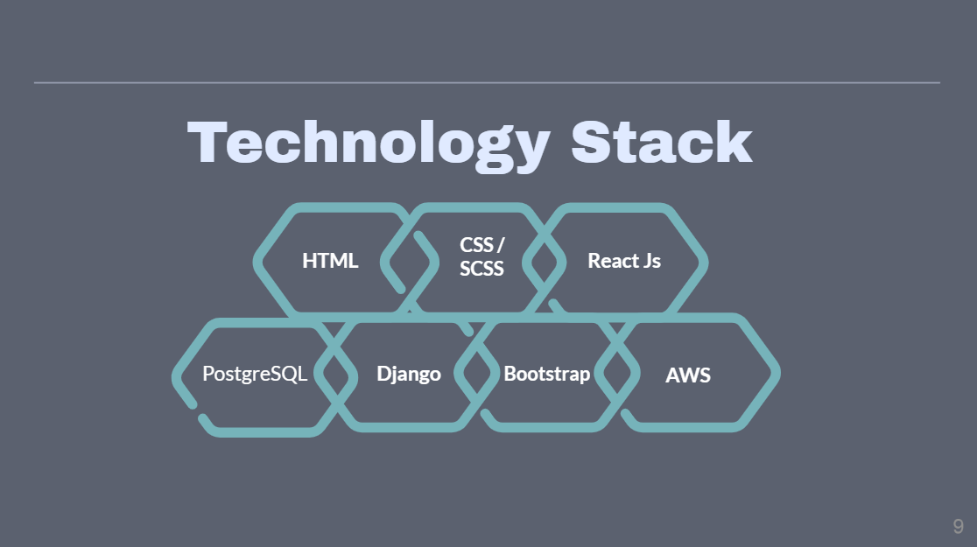

Sitemap:

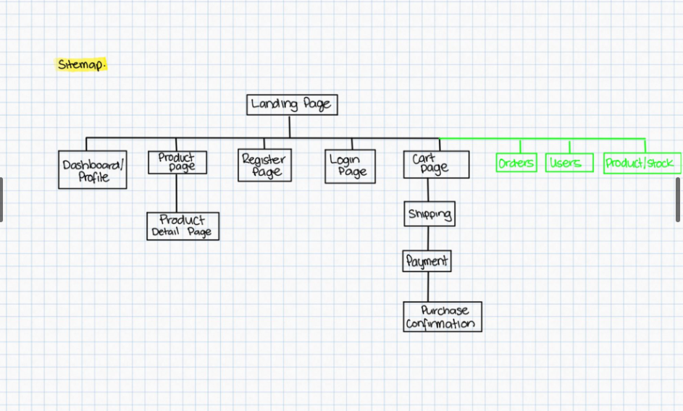

Challenges: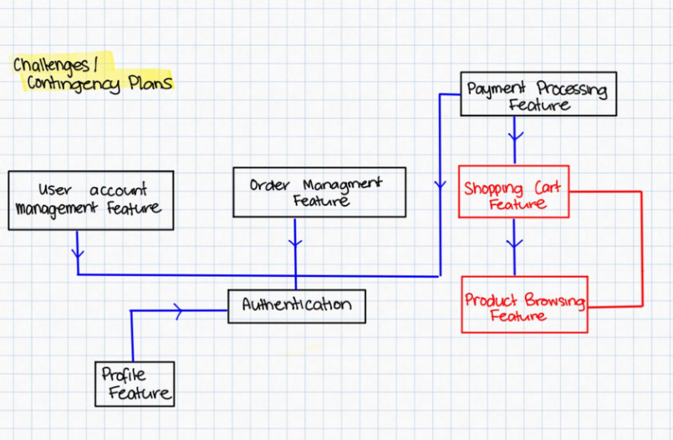

User flow:

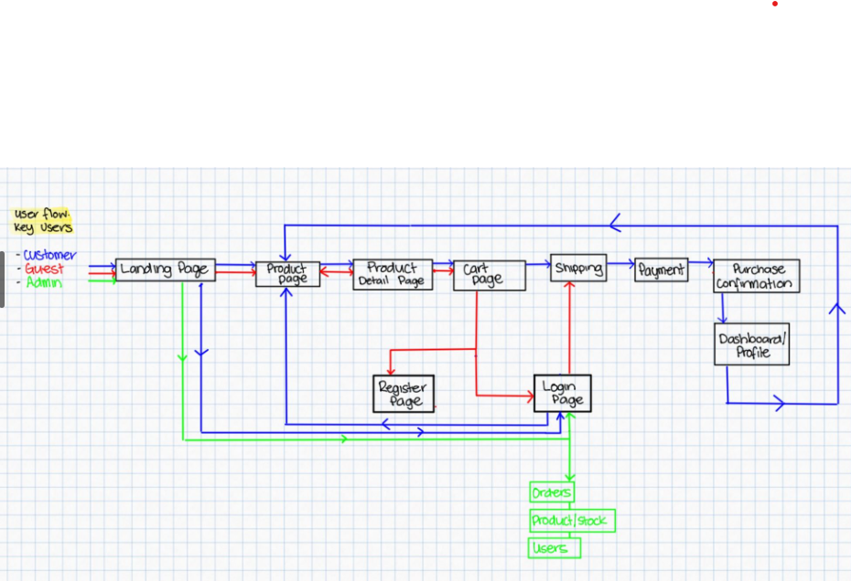

Dependencies: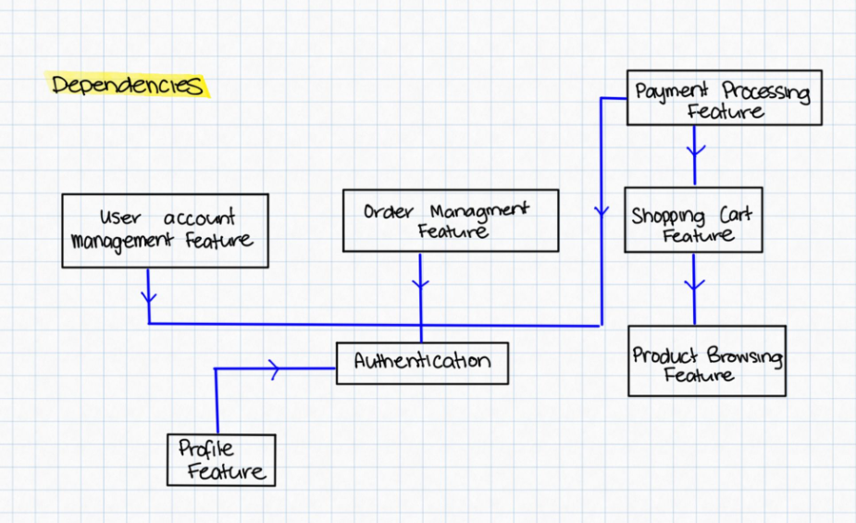

Wireframe example: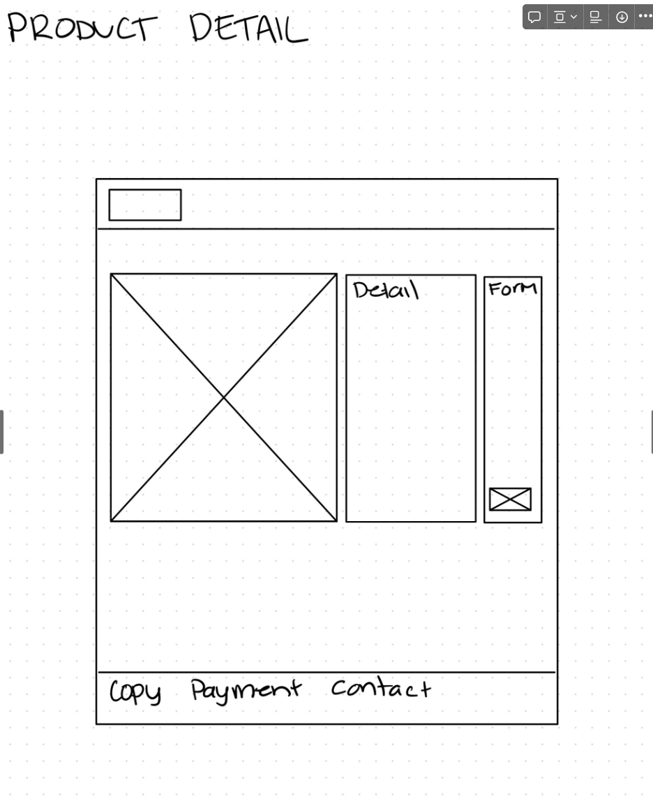

Development Process:

1. Initial set up completed
   1. Initialized git tracking and a GitHub repository
   2. Initialized React front end
   3. Initialized Django backend
   4. Set up folder structure and initial project set up
   5. Installed necessary packages for Django and React

Challenges:

I had difficulty deciding which folders should be tracked and how they should be tracked for example, as a full project, or separately as the frontend and then as the backend. I ultimately decided to track the entire project as have it was stored in a single GitHub repository.

I had difficulty deciding on the folder structure for React whether I would use Slices or not, how I would group components and pages. I decided on a for the React data that the component folder would contain on common React components. The features folder would host the specific feature folders container slices related to each specific feature. The page folder would contain the structural components and the utils folder would contain the helper code associated with the React front end.

### Week 3:

Overview:

There is a complete working project at the moment. The the original mock ups have now come to life and 80% of the sites design in in place and functional with it’s static content (As opposed to dynamically rendered content from a DB and stored Redux state). This means most of the components are built. The front end is also completely set up with server-side routing. The backend is also now in process, I have created the models and will be working on building out the backend, views, serializers, URLs over the next week.

Development Process:

* Built structural components (Pages)
* Built common and reusable components
* Built mock up designs and combined components using locally served static content
* Introduced server side page rendering
* Created models

Challenges:

* Using React for the first time has been an inconvenience but I am conquering the challenge by reading, trial and error.

### Week 4:

Overview:

The backend is logic and design are now in position. The current necessary views, URLs, serializes are in place and the frontend now consuming the backend API and being served information from the backend. Redux system is now in place, utilizing slices and making the necessary API calls to request information from the Django Rest Framework backend. All state has been established and all information throughout the webpage if necessary is being served from the Redux global state.

Development Process:

* Built necessary Views, URLs, Serializers
* Imported all necessary data to Database
* Built out Redux system and constructed all necessary slices
* Established all necessary custom API call actions to DRF backend
* Connected all dynamic components to required global state

Challenges:

* The biggest challenge I faced was trying to understand which information should be requested from the backend and which information should simply be stored as a piece of state. I found no conclusive framework of decision making on the topic and opted for my best judgement on each specific situation. I took into consideration if the information of necessary within the same feature and whether the information was vitally important in being up to date with what was present in the database and the time of request.

### Week 5:

Overview:

This week marked the completion of over 85% of the project, the user authentication system is now in place and the Stripe API has been implemented. The project is near completion, the static images are now being served from AWS S3 buckets and the Database has now been moved to a PostgreSQL database hosted by render.

Development Process:

* Built user authentication login and register with JWT Tokens.
* Integrated Stripe API and web hooks to automatically update database information.
* Integrated AWS S3 buckets and stored necessary static information
* Set up PostgreSQL database and integrated into Django settings

Challenges:

* Aligning the front end validation for the login and register forms with the backend authentication checks in the serializers was challenging but ultimately, I navigated through the challenge.
* I had difficulty setting up the custom web hook from the stripe API to automatically update the database stock after a successful transaction, but researching and reading the documentation I was able to overcome this issue.

### Week 6:

Overview:

This week was to complete writing tests for the Django backend, and fix the remaining bugs present in the application. The application is now live on Render and the project is ready for submission.

Development Process:

* Wrote unit test for the Views, URLs, Serializers and Models.
* Hosted on [Render.com](http://render.com/)
* Bug fixes

Challenges:

* I had trouble Hosting on AWS, the learning curve was a little too steep at this time to learn, so I opted to use the familiar [Render.com](http://render.com/)
* I wrote test with the help of ChatGPT, it was a challenge to design test for the areas I felt important, I felt as though many test if written correctly would be able to cover a range of sub components. I ultimately used the information provided by the AI service to guide me through the test writing process and I feel I was able to cover some of the most important aspects of writing simple unit tests.

Completed Project – 26/2/24